PANTS
PANT/HEM/PLAIN 12.50
PANT/HEM/POLO 12.50
PANT/HEM/JEAN 12.50
PANT/WAISTS AND SIDES/ CENTER WAIST 29.84
PANT/REPAIRS/ SEAM REPAIR 7.40
PANT/ZIPPER/REPLACE ZIPPER 23.16
SHIRTS/SWEATERS
SHIRTS/CRESTS AND BADGES/SEW ON CREST/BADGE 5.00
SHIRTS/CRESTS AND BADGES/REMOVE CREST/BADGE 1.35
SHIRTS/BUTTONS/ SEW ON BUTTON 2.00
SHIRT/REPAIR/REPAIR SEAM 7.40
VESTS
VESTS/CRESTS AND BADGES/SEW ON CREST 5.00/LARGE 7.00/WORK AROUND LINING 5.00
VESTS/CRESTS AND BADGES/ REMOVE CREST/BADGE 1.35

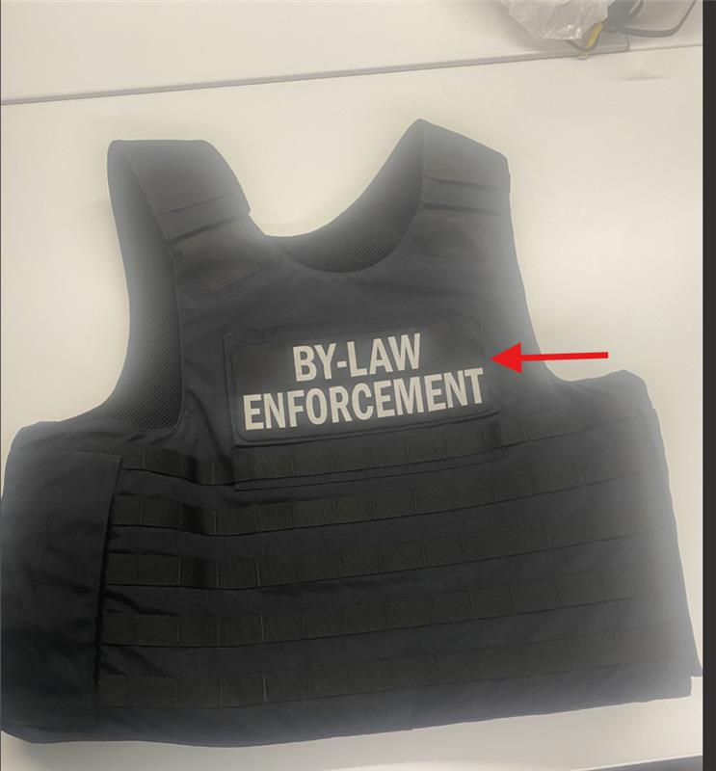

JACKETS
JACKETS/REPAIR/SEAM REPAIR 7.40/LINING 5.00
JACKETS/CRESTS AND BADGES/SEW ON CREST/BADGE 5.00/LINING 5.00
JACKETS/CRESTS AND BADGES/REMOVE CREST/BADGE 1.35
JACKETS/BUTTONS/ SEW ON BUTTON 2.00

