PEEL REGION POLICE SERVICES – DRY CLEANING

ACCOUNT REQUIREMENTS:
Term of agreement: Jan 1st, 2025 – Dec 31st, 2025
BACKGROUND
Peel Regional Police (PRP) issues vouchers annually for the laundering or dry cleaning of uniform and civilian clothing to approximately 2,200 members. Of these Members, approximately 1,650 wear a uniform on a daily basis while the remaining 550 wear business suits, shirts, casual wear or other attire:
A “UNIFORM Garment” consists of dark navy poly/wool blend cargo pants and shirts, dark navy sweater, tunic uniform consisting of a military style jacket and matching pants, dark navy parka.
A “CIVILIAN GARMENT” consists of adult male and/or female business dress (suits, jackets, ties, shirts, dresses, skirts, blouses, etc.) business casual dress (casual slacks, shirts, blouses, sweater, sprots jackets, etc.)
Cleaning vouchers shall not be accepted for cleaning household items such as duvets, curtains, and rugs.
PRP Members are issued cleaning vouchers which are valued at the rates established in the pricing schedule.
PRP Members will pay Stitch It for Services rendered by redeeming cleaning Vouchers supplied to him or her by the Agency.
The Vendor shall not accept cleaning vouchers upfront by PRP Members, prior to any Services being rendered.
Cleaning Vouchers are valid from January 1st through December 31 in the issued year. Expired cleaning vouchers for the year are to be accepted for thirty (30) days after expiry, not beyond. Each cleaning voucher is individually numbered and is tracked by PRP Quartermaster Store Staff, so it is not possible to reproduce the voucher. The color of the vouchers will change in January of each year to identify valid vouchers.
The Vendor shall provide the following minimum level of Service:
- When a PRP Member drops off his or her clothing for cleaning, a tag with the PRP Member’s name and badge number, or a unique customer number, must be affixed immediately to the clothing by the Vendor to ensure that the clothing does not get lost or get mixed in with another customer’s order. (SI)
- The Vendor shall provide an itemized receipt to each PRP Member listing the clothing items dropped off for cleaning. (SI)
- Services shall be completed by the Vendor within three (3) business days of receiving the clothing items for cleaning.
(continued on next page)
- All clothing shall be pressed on steam presses and ensure proper fabric handling. A double clause on shirts and trousers is not acceptable.
- Sleeves on all uniforms and civilian blouses and shirts shall not be creased.
- PRP shall provide replacement uniform buttons to the Vendor at no charge for those uniform buttons missing from clothing items upon delivery to the Vendor. Buttons shall be sewn on by the Vendor at no charge to PRP. PRP shall provide replacement uniform buttons at the expense of the Vendor when the buttons are damaged by the Vendor. The Vendor shall pay for such buttons at the cost price to PRP: (SI and Cleaning Partner)
- All clothing items shall be returned to PRP Members by the Vendor in a cellophane bag identified by a tag identifying the PRP Member by name and badge number or a unique customer number. (SI)
- On a monthly basis, the Vendor shall submit an invoice to the Agency for payment detailing
The quantity and denomination, of the cleaning vouchers redeemed.
- The Vendor shall only submit cleaning vouchers for payment to the agency after cleaning Services have been rendered.
- All redeemed cleaning vouchers submitted by the Vendor must be signed by the PRP Member and include the badge number of the PRP Member.

Department Responsibilities
- Business Development and Sales
- Ensure all contract information is correct and signed copy of agreement sent to Finance.
- Billing information provided to Finance for set up in Netsuite
- Price list to be submitted to Taimoor for entry into SIA along with any special requirements pertaining to account (i.e. bar code, authorization form, badge no. or ID)
- BD to review pricing set up in SIA for accuracy

- Operations
- PRP will be paying for services with “chits”. Chits are to be treated as dollars therefore we will need to create a consistent format for accepting and storing the chits for billing purposes.
- Staff will need to understand the value/denominations required for each dry-cleaning service provided as per the price list
- When a PRP Member drops off his or her clothing for cleaning, a tag with the PRP Member’s name and badge number, or a unique customer number, must be affixed immediately to the clothing by the Vendor to ensure that the clothing does not get lost or get mixed in with another customer’s order.
- The Vendor shall provide an itemized receipt to each PRP Member listing the clothing items dropped off for cleaning.
- All redeemed cleaning vouchers submitted by the Vendor must be signed by the PRP Member and include the badge number of the PRP Member.
- All clothing items shall be returned to PRP Members by the Vendor in a cellophane bag identified by a tag identifying the PRP Member by name and badge number or a unique customer number.

- Customer Service/Account Management
- BD rep. to be primary point of contact for management of account
- Handle resolutions and any changes to the account
- Finance
- Sample of invoice format below:
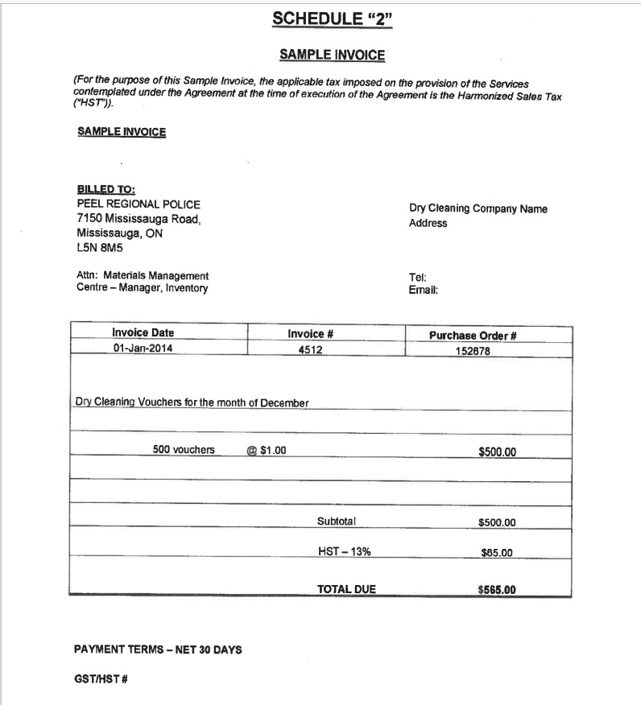

- On a monthly basis, the vendor shall submit an invoice to the Agency for payment detailing the quantity and denomination, as outline in Schedule 1 (approved clothing rates), on cleaning vouchers redeemed.
- All redeemed cleaning vouchers submitted by the Vendor must be signed by the PRP Member and include the badge number of the PRP Member .
- Cleaning prices do not include tax

- All invoices are to be forwarded by the Vendor to one of the following location for payment:

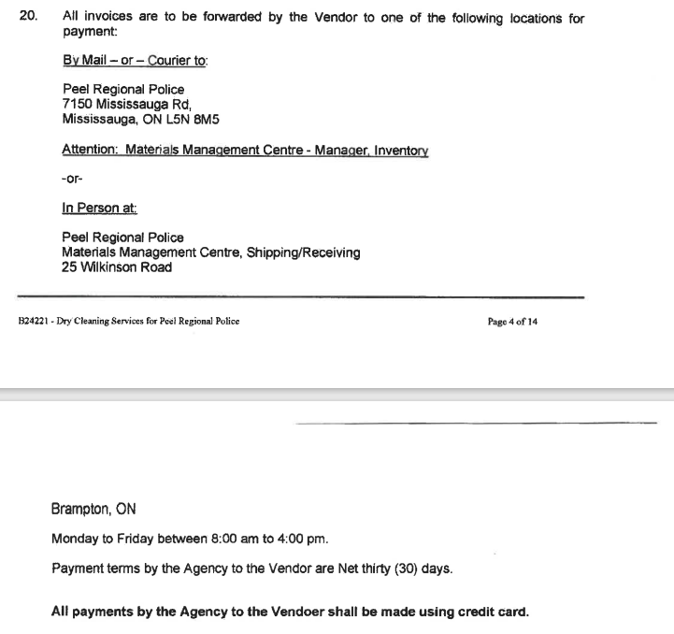

- IT/Systems Support
- Ensure pricing and special instructions for the account are set up properly and accurately
- Training and Quality Control
- Staff to be trained on the dollar value of the chits
- The filing and submission process of the chits
- The particular requirements of the account: i.e. (chits must be signed and include badge number)
- Buttons are to be sewn on for “free”

